Ideation Phase
Define the Problem Statements

Date | 20 February 2026
Team ID | LTVIP2026TMIDS65579
Project Name | Importing & Securing Data in ServiceNow
Maximum Marks | 2 Marks

Customer Problem Statement Template:
1.Customer Persona:
IT administrators, database managers, HR departments, and system analysts who handle large volumes of organizational data in ServiceNow.

2. Problem Description:
Organizations frequently need to import bulk data such as employee records, incident details, customer information, and asset data into the ServiceNow platform. Manual data entry is slow and prone to errors. Additionally, without proper security configurations, sensitive data can be accessed by unauthorized users. Many organizations struggle with correctly mapping imported data and implementing role-based access controls to protect confidential information.

3. Impact of the Problem:
This leads to:
- Data duplication and inconsistencies
- Increased administrative workload
- Security vulnerabilities and data breaches
- Unauthorized access to confidential records
- Reduced operational efficiency

4. Current Alternatives
Currently, organizations:
- Perform manual data uploads
- Use spreadsheets without proper validation
- Apply general access permissions instead of strict role-based control
- Depend on external tools for data cleaning

5.Why Solving This Problem is Important Now
With increasing digital transformation and strict data protection regulations, organizations must ensure secure data handling. Proper data import mechanisms combined with strong security controls in ServiceNow are essential to maintain confidentiality, integrity, and compliance.

Customer Problem Concept Diagram

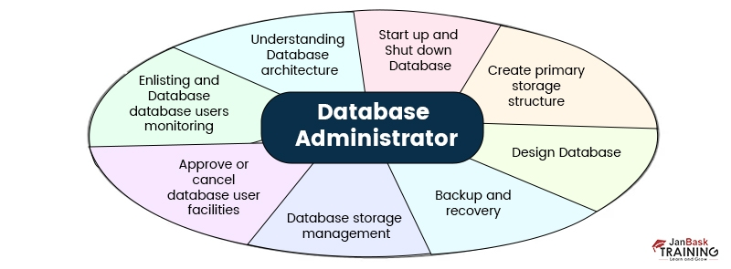
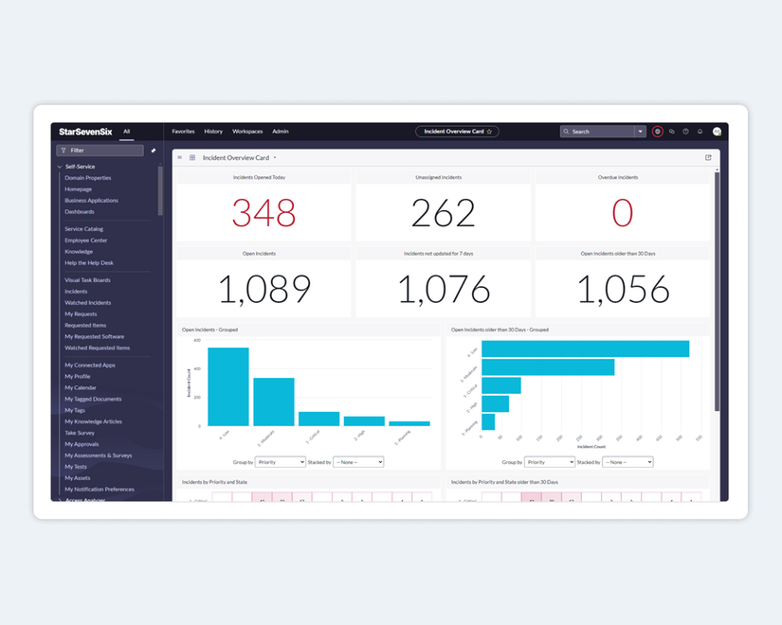
If you want, I can now:
- Convert this into a clean Word-ready formatted page
- Give Implementation Phase content
- Provide Architecture Diagram
- Or prepare Viva Questions & Answers
Tell me what you need next.
Sources

Example:

Problem Statement (PS) | I am (Customer) | I’m trying to | But | Because | Which makes me feel
PS-1
PS-2

